UNITED STATES

SECURITIES AND EXCHANGE COMMISSION

WASHINGTON, D.C. 20549

FORM 6-K

REPORT OF FOREIGN PRIVATE ISSUER PURSUANT

TO RULE 13a-16 or 15d-16 UNDER THE

SECURITIES EXCHANGE ACT OF 1934

For the month of May, 2019

Commission File Number: 001-38452

MEREO BIOPHARMA GROUP PLC

(Translation of registrant’s name into English)

4th Floor, One Cavendish Place,
London, W1G 0QF, United Kingdom

(Address of principal executive office)

Indicate by check mark whether the registrant files or will file annual reports under cover of Form 20-F or Form 40-F.

Form 20-F ☒ Form 40-F ☐

Indicate by check mark if the registrant is submitting the Form 6-K in paper as permitted by Regulation S-T Rule 101(b)(1): ☐

Indicate by check mark if the registrant is submitting the Form 6-K in paper as permitted by Regulation S-T Rule 101(b)(7): ☐

Mereo BioPharma Group plc

("Mereo" or the "Company")

Notification of Director and other PDMR Dealings

London, May 21, 2019 - Mereo BioPharma Group plc (AIM: MPH, NASDAQ: MREO), a clinical stage UK based biopharmaceutical company focused on rare diseases, on May 20, 2019 granted incentive awards as set out below to persons discharging managerial responsibilities (PDMRs). All the awards were granted for nil consideration and shall ordinarily be forfeit (to the extent unvested) upon cessation of service.

Options to acquire American Depositary Shares (“ADSs”) at an exercise price of $5.40 per ADS (Fair Market Value at grant) under the Mereo BioPharma Group plc 2019 Equity Incentive Plan (an employees’ share scheme):

Name of PDMR | Position | Number of ADSs over which
 |  | Option granted
Denise Scots-Knight | Chief Executive Officer | 87,500
Alastair MacKinnon | Chief Medical Officer | 27,500
Richard Jones | Chief Financial Officer | 27,500
Charles Sermon | General Counsel | 27,500
Wills Hughes-Wilson | Head of Patient Access and Commercial Planning | 18,000
John Richard | Head of Corporate Development | 27,500

These Options shall normally vest and become exercisable as to one quarter on the first anniversary of their grant date and, thereafter, as to the balance in equal monthly installments over the three-year period following such anniversary.

Awards to either acquire ADSs at an exercise price of $5.40 per ADS (Fair Market Value at grant) or, at the Company’s discretion, receive a cash amount equal to the excess, if any, over the exercise price of their Fair Market Value on the exercise date:

Name of PDMR | Position | Number of ADSs over which
 |  | Award granted
Peter Fellner | Chairman | 5,500
Anders Ekblom | Director | 5,500
Peter Bains | Director | 5,500
Kunal Kashyap | Director | 5,500
Paul Blackburn | Director | 5,500
Deepa Pakianathan | Director | 5,500
Michael Wyzga | Director | 5,500

These awards shall vest in equal monthly installments over the year following their grant date.

The below announcement and notification is made in accordance with the EU Market Abuse Regulation. The forms required under the EU Market Abuse Regulation follow.
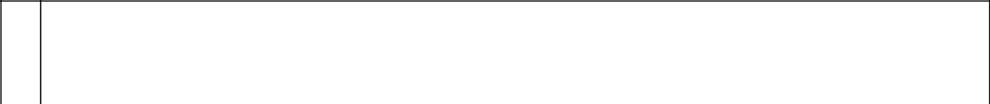

- Details of the person discharging managerial responsibilities

a) Name | Denise Scots-Knight

- Reason for the notification

a) | Position/status | Chief Executive Officer

b) | Initial notification/ Amendment |  |  |  | Initial notification
3 | Details of the issuer, emission allowance market participant, auction platform, auctioneer or auction monitor
a) | Name |  |  |  | Mereo BioPharma Group plc
b) | LEI |  |  |  | 213800U8JQHIJOS5AS09
4 | Details of the transaction(s): section to be repeated for (i) each type of instrument; (ii) each type of transaction; (iii) each date; and (iv)
 | each place where transactions have been conducted
a) | Description | of | the | financial | AMERICAN DEPOSITARY SHARE (ADS), EACH REPRESENTING 5 MEREO BIOPHARMA
 | instrument, | type | of | instrument | GROUP PLC ORDINARY SHARES OF GBP0.003 EACH
 | and identification code
b) | Nature of the transaction |  |  |  | GRANT OF AN OPTION (FOR NO CONSIDERATION) UNDER THE MEREO BIOPHARMA GROUP
 |  |  |  |  | PLC 2019 EQUITY INCENTIVE PLAN. THE EXERCISE PRICE IS US$5.40 PER ADS (FAIR
 |  |  |  |  | MARKET VALUE AT GRANT)
c) | Price(s) and volume(s)
d) | Aggregated |  | information: |  | NOT APPLICABLE – SINGLE TRANSACTION
 | volume, Price
e) | Date of the transaction |  |  |  | May 20, 2019
f) | Place of the transaction |  |  |  | Outside of a trading venue
1 | Details of the person discharging managerial responsibilities
a) | Name |  |  |  | Alastair MacKinnon
2 | Reason for the notification
a) | Position/status |  |  |  | Chief Medical Officer
b) | Initial notification/ Amendment |  |  |  | Initial notification
3 | Details of the issuer, emission allowance market participant, auction platform, auctioneer or auction monitor
a) | Name |  |  |  | Mereo BioPharma Group plc
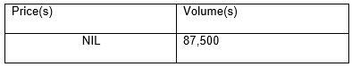

b) LEI | 213800U8JQHIJOS5AS09
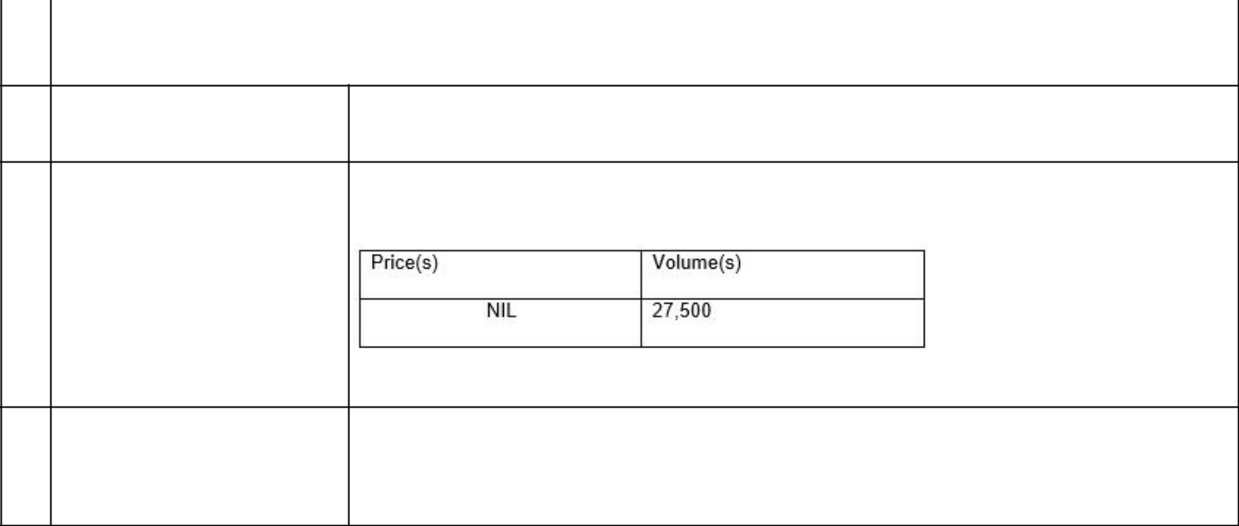
- Details of the transaction(s): section to be repeated for (i) each type of instrument; (ii) each type of transaction; (iii) each date; and (iv) each place where transactions have been conducted

- Description of the financial AMERICAN DEPOSITARY SHARE (ADS), EACH REPRESENTING 5 MEREO BIOPHARMA instrument, type of instrument GROUP PLC ORDINARY SHARES OF GBP0.003 EACH

and identification code

b) | Nature of the transaction | GRANT OF AN OPTION (FOR NO CONSIDERATION) UNDER THE MEREO BIOPHARMA GROUP
 |  | PLC 2019 EQUITY INCENTIVE PLAN. THE EXERCISE PRICE IS US$5.40 PER ADS (FAIR
 |  | MARKET VALUE AT GRANT)
c) | Price(s) and volume(s)

d) | Aggregated | information: NOT APPLICABLE – SINGLE TRANSACTION
 | volume, Price
e) | Date of the transaction |  | May 20, 2019
f) | Place of the transaction |  | Outside of a trading venue
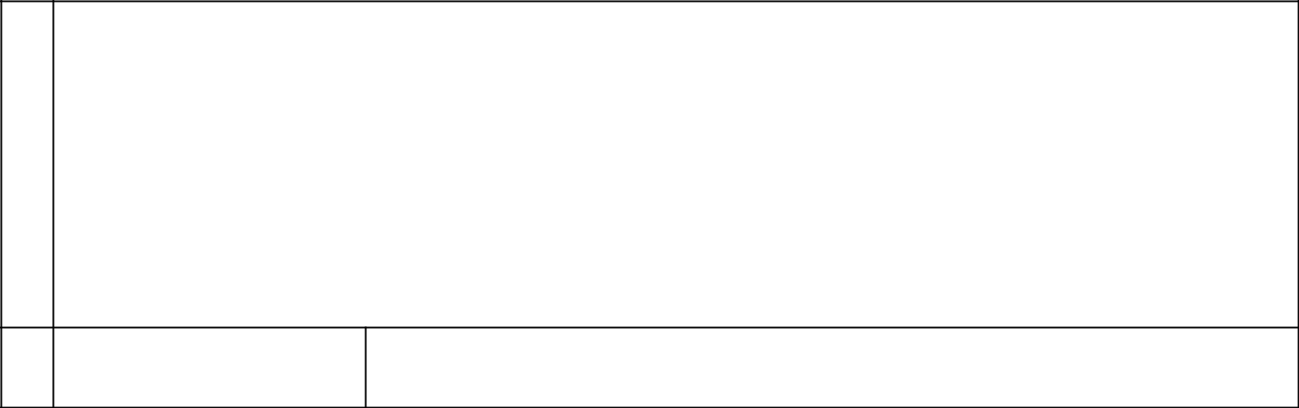

- Details of the person discharging managerial responsibilities

a) Name | Richard Jones

- Reason for the notification

a) | Position/status | Chief Financial Officer
b) | Initial notification/ Amendment | Initial notification

- Details of the issuer, emission allowance market participant, auction platform, auctioneer or auction monitor

a) | Name | Mereo BioPharma Group plc
b) | LEI | 213800U8JQHIJOS5AS09

- Details of the transaction(s): section to be repeated for (i) each type of instrument; (ii) each type of transaction; (iii) each date; and (iv) each place where transactions have been conducted

- Description of the financial AMERICAN DEPOSITARY SHARE (ADS), EACH REPRESENTING 5 MEREO BIOPHARMA instrument, type of instrument GROUP PLC ORDINARY SHARES OF

and

 | identification code |  |  |  | GBP0.003 EACH
b) | Nature of the transaction |  |  |  | GRANT OF AN OPTION (FOR NO CONSIDERATION) UNDER THE MEREO BIOPHARMA GROUP
 |  |  |  |  | PLC 2019 EQUITY INCENTIVE PLAN. THE EXERCISE PRICE IS US$5.40 PER ADS (FAIR
 |  |  |  |  | MARKET VALUE AT GRANT)
c) | Price(s) and volume(s)
d) | Aggregated |  | information: |  | NOT APPLICABLE – SINGLE TRANSACTION
 | volume, Price
e) | Date of the transaction |  |  |  | May 20, 2019
f) | Place of the transaction |  |  |  | Outside of a trading venue
1 | Details of the person discharging managerial responsibilities
a) | Name |  |  |  | Charles Sermon
2 | Reason for the notification
a) | Position/status |  |  |  | General Counsel
b) | Initial notification/ Amendment |  |  |  | Initial notification
3 | Details of the issuer, emission allowance market participant, auction platform, auctioneer or auction monitor
a) | Name |  |  |  | Mereo BioPharma Group plc
b) | LEI |  |  |  | 213800U8JQHIJOS5AS09
4 | Details of the transaction(s): section to be repeated for (i) each type of instrument; (ii) each type of transaction; (iii) each date; and (iv)
 | each place where transactions have been conducted
a) | Description | of | the | financial | AMERICAN DEPOSITARY SHARE (ADS), EACH REPRESENTING 5 MEREO BIOPHARMA
 | instrument, | type | of | instrument | GROUP PLC ORDINARY SHARES OF GBP0.003 EACH
 | and identification code
b) | Nature of the transaction |  |  |  | GRANT OF AN OPTION (FOR NO CONSIDERATION) UNDER THE MEREO BIOPHARMA GROUP
 |  |  |  |  | PLC 2019 EQUITY INCENTIVE PLAN. THE EXERCISE PRICE IS US$5.40 PER ADS (FAIR
 |  |  |  |  | MARKET VALUE AT GRANT)
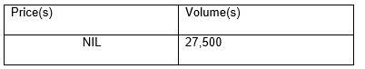


- Price(s) and volume(s)

d) | Aggregated |  | information: NOT APPLICABLE – SINGLE TRANSACTION
 | volume, Price
e) | Date of the transaction |  |  |  | May 20, 2019
f) | Place of the transaction |  |  |  | Outside of a trading venue
1 | Details of the person discharging managerial responsibilities
a) | Name |  |  |  | Wills Hughes-Wilson
2 | Reason for the notification
a) | Position/status |  |  |  | Head of Patient Access and Commercial Planning
b) | Initial notification/ Amendment |  |  |  | Initial notification
3 | Details of the issuer, emission allowance market participant, auction platform, auctioneer or auction monitor
a) | Name |  |  |  | Mereo BioPharma Group plc
b) | LEI |  |  |  | 213800U8JQHIJOS5AS09
4 | Details of the transaction(s): section to be repeated for (i) each type of instrument; (ii) each type of transaction; (iii) each date; and (iv)
 | each place where transactions have been conducted
a) | Description | of | the | financial | AMERICAN DEPOSITARY SHARE (ADS), EACH REPRESENTING 5 MEREO BIOPHARMA
 | instrument, | type | of | instrument | GROUP PLC ORDINARY SHARES OF GBP0.003 EACH
 | and identification code
b) | Nature of the transaction |  |  |  | GRANT OF AN OPTION (FOR NO CONSIDERATION) UNDER THE MEREO BIOPHARMA GROUP
 |  |  |  |  | PLC 2019 EQUITY INCENTIVE PLAN. THE EXERCISE PRICE IS US$5.40 PER ADS (FAIR
 |  |  |  |  | MARKET VALUE AT GRANT)
c) | Price(s) and volume(s)
d) | Aggregated |  | information: |  | NOT APPLICABLE – SINGLE TRANSACTION
 | volume,
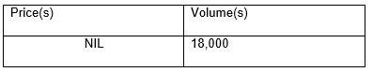

 | Price
e) | Date of the transaction |  |  |  | May 20, 2019
f) | Place of the transaction |  |  |  | Outside of a trading venue
1 | Details of the person discharging managerial responsibilities
a) | Name |  |  |  | John Richard
2 | Reason for the notification
a) | Position/status |  |  |  | Head of Corporate Development
b) | Initial notification/ Amendment |  |  |  | Initial notification
3 | Details of the issuer, emission allowance market participant, auction platform, auctioneer or auction monitor
a) | Name |  |  |  | Mereo BioPharma Group plc
b) | LEI |  |  |  | 213800U8JQHIJOS5AS09
4 | Details of the transaction(s): section to be repeated for (i) each type of instrument; (ii) each type of transaction; (iii) each date; and (iv)
 | each place where transactions have been conducted
a) | Description | of | the | financial | AMERICAN DEPOSITARY SHARE (ADS), EACH REPRESENTING 5 MEREO BIOPHARMA
 | instrument, | type | of | instrument | GROUP PLC ORDINARY SHARES OF GBP0.003 EACH
 | and identification code
b) | Nature of the transaction |  |  |  | GRANT OF AN OPTION (FOR NO CONSIDERATION) UNDER THE MEREO BIOPHARMA GROUP
 |  |  |  |  | PLC 2019 EQUITY INCENTIVE PLAN. THE EXERCISE PRICE IS US$5.40 PER ADS (FAIR
 |  |  |  |  | MARKET VALUE AT GRANT)
c) | Price(s) and volume(s)
d) | Aggregated |  | information: |  | NOT APPLICABLE – SINGLE TRANSACTION
 | volume, Price
e) | Date of the transaction |  |  |  | May 20, 2019
f) | Place of the transaction |  |  |  | Outside of a trading venue

1 | Details of the person discharging managerial responsibilities
a) | Name |  |  |  | Peter Fellner
2 | Reason for the notification
a) | Position/status |  |  |  | Chairman
b) | Initial notification/ Amendment |  |  |  | Initial notification
3 | Details of the issuer, emission allowance market participant, auction platform, auctioneer or auction monitor
a) | Name |  |  |  | Mereo BioPharma Group plc
b) | LEI |  |  |  | 213800U8JQHIJOS5AS09
4 | Details of the transaction(s): section to be repeated for (i) each type of instrument; (ii) each type of transaction; (iii) each date; and (iv)
 | each place where transactions have been conducted
a) | Description | of | the | financial | AMERICAN DEPOSITARY SHARE (ADS), EACH REPRESENTING 5 MEREO BIOPHARMA
 | instrument, | type | of | instrument | GROUP PLC ORDINARY SHARES OF GBP0.003 EACH
 | and identification code
b) | Nature of the transaction |  |  |  | GRANT OF AN AWARD (FOR NO CONSIDERATION) UNDER THE MEREO BIOPHARMA GROUP
 |  |  |  |  | PLC 2019 NON-EMPLOYEE EQUITY INCENTIVE PLAN. THE EXERCISE PRICE IS US$5.40 PER
 |  |  |  |  | ADS (FAIR MARKET VALUE AT GRANT). ON EXERCISE, THE COMPANY HAS DISCRETION
 |  |  |  |  | EITHER TO DELIVER ADSS OR MAKE A CASH PAYMENT EQUAL TO ANY EXCESS OF THEIR
 |  |  |  |  | FAIR MARKET VALUE OVER THE EXERCISE PRICE
c) | Price(s) and volume(s)
d) | Aggregated |  | information: |  | NOT APPLICABLE – SINGLE TRANSACTION
 | volume, Price
e) | Date of the transaction |  |  |  | May 20, 2019
f) | Place of the transaction |  |  |  | Outside of a trading venue
1 | Details of the person discharging managerial responsibilities
a) | Name |  |  |  |  | Anders Ekblom
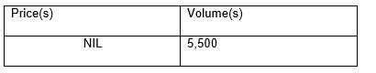

- Reason for the notification

a) | Position/status |  | Director
b) | Initial notification/ Amendment |  | Initial notification
3 | Details of the issuer, emission allowance market participant, auction platform, auctioneer or auction monitor
a) | Name |  | Mereo BioPharma Group plc
b) | LEI |  | 213800U8JQHIJOS5AS09
4 | Details of the transaction(s): section to be repeated for (i) each type of instrument; (ii) each type of transaction; (iii) each date; and (iv)
 | each place where transactions have been conducted
a) | Description of the | financial | AMERICAN DEPOSITARY SHARE (ADS), EACH REPRESENTING 5 MEREO BIOPHARMA
 | instrument, type of instrument and |  | GROUP PLC ORDINARY SHARES OF GBP0.003 EACH
 | identification code
b) | Nature of the transaction |  | GRANT OF AN AWARD (FOR NO CONSIDERATION) UNDER THE MEREO BIOPHARMA GROUP
 |  |  | PLC 2019 NON-EMPLOYEE EQUITY INCENTIVE PLAN. THE EXERCISE PRICE IS US$5.40 PER
 |  |  | ADS (FAIR MARKET VALUE AT GRANT). ON EXERCISE, THE COMPANY HAS DISCRETION
 |  |  | EITHER TO DELIVER ADSS OR MAKE A CASH PAYMENT EQUAL TO ANY EXCESS OF THEIR
 |  |  | FAIR MARKET VALUE OVER THE EXERCISE PRICE
c) | Price(s) and volume(s)
d) | Aggregated information: | volume, | NOT APPLICABLE – SINGLE TRANSACTION
 | Price
e) | Date of the transaction |  | May 20, 2019
f) | Place of the transaction |  | Outside of a trading venue
1 | Details of the person discharging managerial responsibilities
a) | Name |  | Peter Bains
2 | Reason for the notification
a) | Position/status |  | Director

b) Initial notification/ Amendment | Initial notification
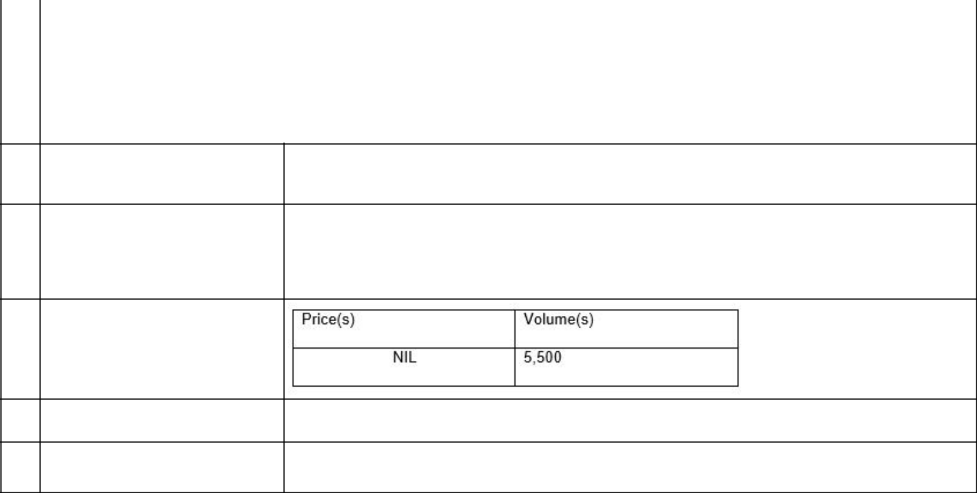
- Details of the issuer, emission allowance market participant, auction platform, auctioneer or auction monitor

a) | Name | Mereo BioPharma Group plc
b) | LEI | 213800U8JQHIJOS5AS09

- Details of the transaction(s): section to be repeated for (i) each type of instrument; (ii) each type of transaction; (iii) each date; and (iv) each place where transactions have been conducted

- Description of the financial AMERICAN DEPOSITARY SHARE (ADS), EACH REPRESENTING 5 MEREO BIOPHARMA instrument, type of instrument and GROUP PLC ORDINARY SHARES OF GBP0.003 EACH

identification code

b) Nature of the transaction | GRANT OF AN AWARD (FOR NO CONSIDERATION) UNDER THE MEREO BIOPHARMA GROUP
 | PLC 2019 NON-EMPLOYEE EQUITY INCENTIVE PLAN. THE EXERCISE PRICE IS US$5.40 PER
 | ADS (FAIR MARKET VALUE AT GRANT). ON EXERCISE, THE COMPANY HAS DISCRETION
 | EITHER TO DELIVER ADSS OR MAKE A CASH PAYMENT EQUAL TO ANY EXCESS OF THEIR
 | FAIR MARKET VALUE OVER THE EXERCISE PRICE

- Price(s) and volume(s)

- Aggregated information: volume, NOT APPLICABLE – SINGLE TRANSACTION Price

e) | Date of the transaction | May 20, 2019
f) | Place of the transaction | Outside of a trading venue


- Details of the person discharging managerial responsibilities

a) Name | Kunal Kashyap

- Reason for the notification

a) | Position/status | Director
b) | Initial notification/ Amendment | Initial notification

- Details of the issuer, emission allowance market participant, auction platform, auctioneer or

 | auction monitor
a) | Name |  |  | Mereo BioPharma Group plc
b) | LEI |  |  | 213800U8JQHIJOS5AS09
4 | Details of the transaction(s): section to be repeated for (i) each type of instrument; (ii) each type of transaction; (iii) each date; and (iv)
 | each place where transactions have been conducted
a) | Description of the | financial |  | AMERICAN DEPOSITARY SHARE (ADS), EACH REPRESENTING 5 MEREO BIOPHARMA
 | instrument, type of instrument and |  |  | GROUP PLC ORDINARY SHARES OF GBP0.003 EACH
 | identification code
b) | Nature of the transaction |  |  | GRANT OF AN AWARD (FOR NO CONSIDERATION) UNDER THE MEREO BIOPHARMA GROUP
 |  |  |  | PLC 2019 NON-EMPLOYEE EQUITY INCENTIVE PLAN. THE EXERCISE PRICE IS US$5.40 PER
 |  |  |  | ADS (FAIR MARKET VALUE AT GRANT). ON EXERCISE, THE COMPANY HAS DISCRETION
 |  |  |  | EITHER TO DELIVER ADSS OR MAKE A CASH PAYMENT EQUAL TO ANY EXCESS OF THEIR
 |  |  |  | FAIR MARKET VALUE OVER THE EXERCISE PRICE
c) | Price(s) and volume(s)
d) | Aggregated information: | volume, |  | NOT APPLICABLE – SINGLE TRANSACTION
 | Price
e) | Date of the transaction |  |  | May 20, 2019
f) | Place of the transaction |  |  | Outside of a trading venue
1 | Details of the person discharging managerial responsibilities
a) | Name |  | Paul Blackburn
2 | Reason for the notification
a) | Position/status |  | Director
b) | Initial notification/ Amendment |  | Initial notification
3 | Details of the issuer, emission allowance market participant, auction platform, auctioneer or auction monitor
a) | Name |  | Mereo BioPharma Group plc

b) LEI | 213800U8JQHIJOS5AS09
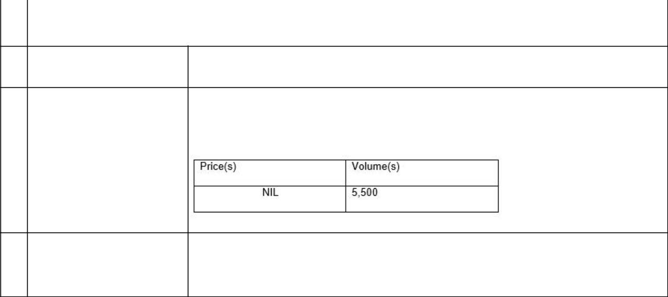
- Details of the transaction(s): section to be repeated for (i) each type of instrument; (ii) each type of transaction; (iii) each date; and (iv) each place where transactions have been conducted

- Description of the financial AMERICAN DEPOSITARY SHARE (ADS), EACH REPRESENTING 5 MEREO BIOPHARMA instrument, type of instrument GROUP PLC ORDINARY SHARES OF GBP0.003 EACH

and identification code

b) | Nature of the transaction | GRANT OF AN AWARD (FOR NO CONSIDERATION) UNDER THE MEREO BIOPHARMA GROUP
 |  | PLC 2019 NON-EMPLOYEE EQUITY INCENTIVE PLAN. THE EXERCISE PRICE IS US$5.40 PER
 |  | ADS (FAIR MARKET VALUE AT GRANT). ON EXERCISE, THE COMPANY HAS DISCRETION
 |  | EITHER TO DELIVER ADSS OR MAKE A CASH PAYMENT EQUAL TO ANY EXCESS OF THEIR
 |  | FAIR MARKET VALUE OVER THE EXERCISE PRICE
c) | Price(s) and volume(s)

d) | Aggregated | information: NOT APPLICABLE – SINGLE TRANSACTION
 | volume, Price
e) | Date of the transaction |  | May 20, 2019
f) | Place of the transaction |  | Outside of a trading venue


- Details of the person discharging managerial responsibilities

a) Name | Deepa Pakianathan

- Reason for the notification

a) | Position/status | Director
b) | Initial notification/ Amendment | Initial notification

- Details of the issuer, emission allowance market participant, auction platform, auctioneer or auction monitor

a) | Name | Mereo BioPharma Group plc
b) | LEI | 213800U8JQHIJOS5AS09

- Details of the transaction(s): section to be repeated for (i) each type of instrument; (ii) each type of transaction; (iii) each date; and (iv) each place where transactions have been conducted

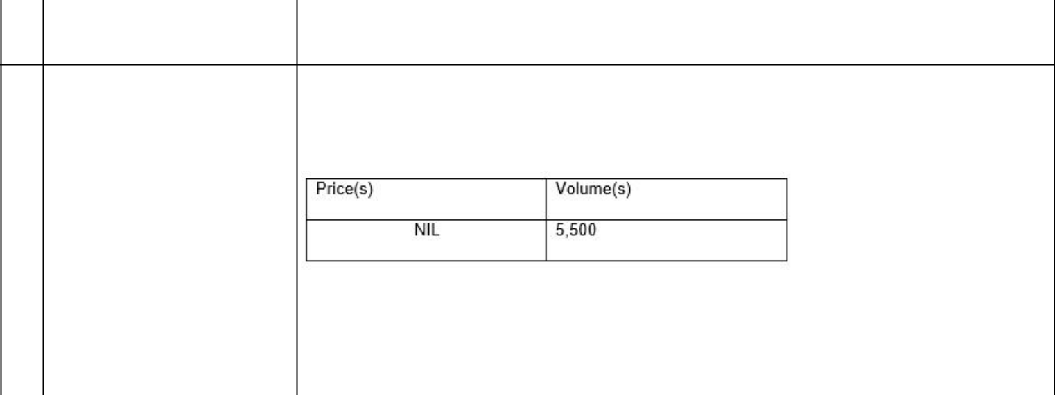
- Description of the financial AMERICAN DEPOSITARY SHARE (ADS), EACH REPRESENTING 5 MEREO BIOPHARMA instrument, type of instrument GROUP PLC ORDINARY SHARES OF GBP0.003 EACH

and identification code

b) | Nature of the transaction |  |  |  | GRANT OF AN AWARD (FOR NO CONSIDERATION) UNDER THE MEREO BIOPHARMA GROUP
 |  |  |  |  | PLC 2019 NON-EMPLOYEE EQUITY INCENTIVE PLAN. THE EXERCISE PRICE IS US$5.40 PER
 |  |  |  |  | ADS (FAIR MARKET VALUE AT GRANT). ON EXERCISE, THE COMPANY HAS DISCRETION
 |  |  |  |  | EITHER TO DELIVER ADSS OR MAKE A CASH PAYMENT EQUAL TO ANY EXCESS OF THEIR
 |  |  |  |  | FAIR MARKET VALUE OVER THE EXERCISE PRICE
c) | Price(s) and volume(s)
d) | Aggregated |  | information: NOT APPLICABLE – SINGLE TRANSACTION
 | volume, Price
e) | Date of the transaction |  |  |  | May 20, 2019
f) | Place of the transaction |  |  |  | Outside of a trading venue
1 | Details of the person discharging managerial responsibilities
a) | Name |  |  |  | Michael Wyzga
2 | Reason for the notification
a) | Position/status |  |  |  | Director
b) | Initial notification/ Amendment |  |  |  | Initial notification
3 | Details of the issuer, emission allowance market participant, auction platform, auctioneer or auction monitor
a) | Name |  |  |  | Mereo BioPharma Group plc
b) | LEI |  |  |  | 213800U8JQHIJOS5AS09
4 | Details of the transaction(s): section to be repeated for (i) each type of instrument; (ii) each type of transaction; (iii) each date; and (iv)
 | each place where transactions have been conducted
a) | Description | of | the | financial | AMERICAN DEPOSITARY SHARE (ADS), EACH REPRESENTING 5 MEREO BIOPHARMA
 | instrument, | type | of | instrument | GROUP PLC ORDINARY SHARES OF GBP0.003 EACH
 | and identification code

b) | Nature of the transaction |  | GRANT OF AN AWARD (FOR NO CONSIDERATION) UNDER THE MEREO BIOPHARMA GROUP
 |  |  | PLC 2019 NON-EMPLOYEE EQUITY INCENTIVE PLAN. THE EXERCISE PRICE IS US$5.40 PER
 |  |  | ADS (FAIR MARKET VALUE AT GRANT). ON EXERCISE, THE COMPANY HAS DISCRETION
 |  |  | EITHER TO DELIVER ADSS OR MAKE A CASH PAYMENT EQUAL TO ANY EXCESS OF THEIR
 |  |  | FAIR MARKET VALUE OVER THE EXERCISE PRICE
c) | Price(s) and volume(s)
d) | Aggregated | information: | NOT APPLICABLE – SINGLE TRANSACTION
 | volume, Price
e) | Date of the transaction |  | May 20, 2019
f) | Place of the transaction |  | Outside of a trading venue

SIGNATURE

Pursuant to the requirements of the Securities Exchange Act of 1934, the registrant has duly caused this report to be signed on its behalf by the undersigned, thereunto duly authorized.

Date: May 21, 2019

MEREO BIOPHARMA GROUP PLC

By: | /s/ Charles Sermon
 | Name: | Charles Sermon
 | Title: | General Counsel

